1135 Waivers (Federally Declared Disasters)

BACKGROUND

At the request of the Governor of an affected State, the President may, under the authority of the Robert
- Stafford Disaster Relief and Emergency Act, declare a major disaster or emergency if an event is beyond the combined response capabilities of the State and affected local governments. If a Presidential declaration occurs, the HHS Secretary may, under section 319 of the Public Health Service Act, declare that a Public Health Emergency (PHE) exists in the affected State. Once a PHE is declared, section 1135 of the Social Security Act authorizes the Secretary, among other things, to temporarily modify or waive certain Medicare, Medicaid, CHIP, and HIPAA requirements as determined necessary by CMS.

CMS helps states and U.S. territories to maintain access to care for those with Medicare and Medicaid by supporting the ability of participating hospitals and other healthcare facilities to provide timely care to as many people impacted by an emergency or disaster as possible. CMS will exercise allowable flexibilities and issue waivers as needed to accommodate the needs of those impacted by an emergency or disaster. Specific waivers granted as a result of the emergency or disaster may be retroactive to the beginning of the emergency or disaster if warranted. CMS also has the authority to exercise certain flexibilities, which are agency policies or procedures that can be adjusted under current authority – and generally speaking, can be adjusted without reprogramming CMS’s systems.

Under Section 1135 or 1812(f) of the Social Security Act, CMS can issue several blanket waivers as a result of a disaster or emergency. These waivers will prevent gaps in access to care for beneficiaries impacted by the emergency. Providers do not need to apply for an individual waiver if a blanket waiver has been issued. Providers can request an individual Section 1135 waiver, if there is no blanket waiver.

Alternate care sites: In the event of a disaster or public health emergency, Alternate Care Sites (ACS) may be created to enable healthcare providers to care for injured or sick patients or distribute vaccines and other types of prophylaxis. A government-authorized Alternate Care Site DOES include mobile field hospitals, schools, shuttered hospitals, stadiums, arenas, churches, and other facilities not currently licensed to provide healthcare services that, under the authority of local government, are designated as an Alternate Care Site to help absorb the patient load after all other healthcare resources are exhausted.

The 1135 waiver authority applies only to Federal requirements and does not apply to State requirements for licensure or conditions of participation.

POLICY

In the event of a major disaster involving an 1135 Waiver, this facility will coordinate with and follow instructions from the local response authorities, State Survey Agency, and Federal authorities regarding alternate care sites, or other provisions applicable under that Waiver.

If a disaster or emergency is declared under the Stafford Act or National Emergencies Act and the HHS Secretary declares a public health emergency under Section 319 of the Public Health Service Act, the facility may find it necessary to request an 1135 Waiver in order to continue to provide care to the clients at an alternate care site identified by the emergency management officials.

PROCEDURES

The facility will utilize the California standards and guidelines manual:

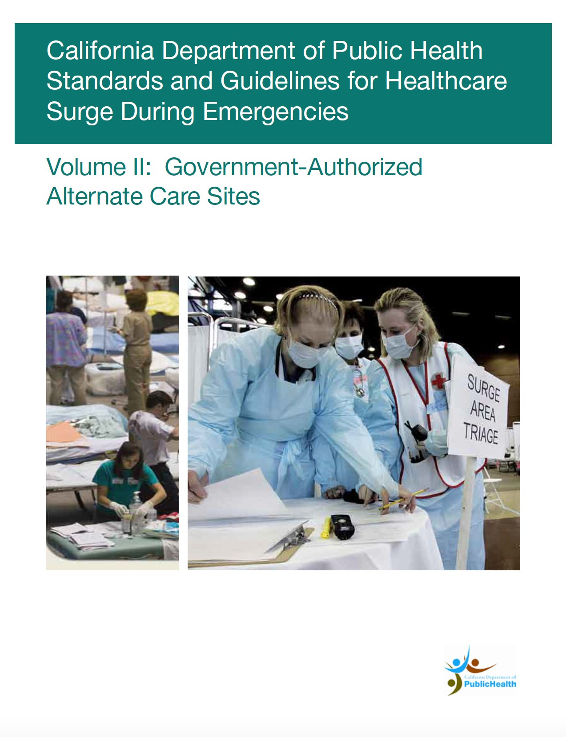
California Department of Public Health Standards and Guidelines for Healthcare Surge During EmergenciesVolume II:
Government-Authorized Alternate Care Sites

to assist the facility in responding to a healthcare surge and a relocation to an alternate care site. This manual contains planning information related to the establishment of government-authorized Alternate Care Sites that may be used for healthcare delivery during a healthcare surge. It includes specific guidance and general planning considerations for coordinating site locations, developing staffing models, defining standards of care and developing administrative protocols. Specific guidance on federal and State reimbursement at government-authorized alternate care sites is also provided.

This manual is 157 pages in length and will be maintained by the Corporate Office. The facility will initiate the following procedure to request an 1135 waiver:
The facility will request the waiver to the appropriate CMS Regional Office with a copy to the local CDPH office to insure the waiver request does not conflict with any State requirements.

The request will contain the following information:

  - Name of the facility and licensure type
  - Full Address (including county/city/town/state)
  - Contact person and his or her contact information for follow-up questions should the Region need additional clarification
  - Brief summary of why the waiver is needed. Some examples of a waiver request might include:
    - ‘Facility’ is sole community provider without reasonable transfer options at this point during the specified emergent event (e.g. flooding, earthquake, fires, or flu outbreak). ‘Facility’ needs a waiver to exceed its bed limit by X number of beds for Y days/weeks.
    - ‘Facility’ has been relocated to an alternate site under the direction of emergency management officials. ‘Facility’ needs a waiver to continue to provide client care at the alternate care site.

  - Consideration – we will request the type of relief we are seeking or regulatory requirements or regulatory reference that we are seeking to be waived.
  - There is no specific form or format that is required to submit the information but we will clearly
state the scope of the issue and the impact to our facility.

The CMS Regional Office to submit the waiver request to is: ROSFOSO@cms.hhs.gov

